PERSONAL FINANCE
ADVISOR BOT
AI-Powered Personal Financial Planning and Budget Management Platform
Project Documentation

Core Purpose | Income tracking, expense management, budgeting, savings monitoring, financial reporting and AI-assisted guidance
Backend | Flask + SQLAlchemy
AI Layer | AI-powered financial analysis and recommendation engine
Additional Tools | Python 3.8 or above + AWS CLI (latest version)

1. Executive Summary
The Personal Finance Advisor Bot is an AI-powered financial planning assistant developed to help individuals take control of their personal finances with clarity and confidence. The system provides a centralized environment for recording monthly income, logging daily and weekly expenses by category, generating personalized budget plans, tracking savings progress, and producing structured monthly financial reports.
The platform combines a scalable full-stack architecture based on Flask and SQLAlchemy with an AI engine for financial analysis. By automating budget generation and organizing financial information into dashboards, the system reduces the complexity of manual financial tracking and provides actionable saving recommendations.
Project Focus
The application is designed around practical personal-finance workflows: know the income, record spending, compare spending with the budget, monitor savings, understand trends, and receive AI-assisted guidance.

2. Project Overview
The Personal Finance Advisor Bot acts as a centralized digital environment for personal financial management. Users can record income sources, categorize expenses, establish monthly budgets, monitor savings goals, review transactions, and access an AI advisor. The dashboard consolidates these activities into an easy-to-understand financial overview.
The platform is intended to support both fixed-income and variable-income users. A salaried professional can track a predictable monthly salary, while a freelancer can record earnings from multiple clients and adapt planning to changing income. The same architecture can support students and household managers with suitable budget categories and goals.

3. Objectives
- Provide a centralized platform for recording and organizing personal income and expenses.
- Track daily and weekly expenses using meaningful financial categories.
- Generate personalized monthly budgets based on income and spending information.
- Identify overspending areas and present clear budget-limit notifications.
- Track savings progress against defined monthly or long-term goals.
- Provide AI-powered financial insights and practical saving recommendations.
- Generate structured monthly reports showing income, expenses, savings and trends.
- Support variable-income planning for users such as freelancers.
- Reduce the manual effort required to maintain personal financial records.
- Provide a scalable architecture that can support future predictive and goal-based financial features.

4. Core Functional Modules
Module | Purpose
Dashboard | Provides the financial overview for the selected month, including income, expenses, savings, savings rate, budget progress and AI-generated insights.
Income Management | Allows users to record and monitor salary and other income sources such as freelance payments or interest.
Expense Management | Records spending and organizes it into categories such as rent, food, transport, shopping, education, entertainment and utilities.
Budget Planner | Compares planned amounts with actual spending, identifies over-budget categories and displays the remaining budget.
AI Advisor | Provides conversational financial analysis, saving suggestions and budget recommendations based on the user's recorded information.
Savings & Goals | Tracks progress toward savings goals such as an emergency fund and monthly savings targets.
Reports | Provides month-over-month comparisons, income-versus-expense views and category spending trends.
Transactions | Displays transaction date, description, category, type, payment method, amount and completion status.
Notifications | Highlights budget-limit exceedances, report availability, savings progress and unusual spending patterns.
Profile & Settings | Stores user profile details, user type, monthly income, currency and notification preferences.

5. System Architecture
The platform follows a modular full-stack architecture in which the user interface communicates with backend services responsible for data management, budget processing and AI-driven financial analysis.

5.1 Presentation Layer
- Responsive web interface for dashboard and financial management pages.
- Forms for entering income, expenses, budgets and financial questions.
- Cards, progress bars, charts, indicators and notification components.
- Navigation for Dashboard, Income, Expenses, Budget Planner, AI Advisor, Savings & Goals, Reports, Transactions, Notifications and Settings.

5.2 Application / Backend Layer
- Flask provides the web application and backend service layer.
- Business logic processes income, expenses, budgets, savings and reporting operations.
- SQLAlchemy provides the database interaction and object-relational mapping layer.
- The backend can expose structured data to dashboard components and the AI analysis layer.

5.3 AI Analysis Layer
- The AI engine analyzes recorded financial information.
- It generates personalized financial insights and saving suggestions.
- It can identify overspending patterns and explain budget-related observations in conversational language.
- The architecture leaves room for future predictive spending analytics and financial-health monitoring.

5.4 Data Layer
- Stores user profile information and financial preferences.
- Stores income records, expense transactions, budget allocations, savings goals and reporting data.
- Supports structured historical information for month-over-month analysis.

6. Technology Stack
Technology Area | Technology / Role
Frontend | HTML, CSS, JavaScript and responsive dashboard components
Backend | Python with Flask
Database / ORM | SQLAlchemy
AI | AI-driven financial analysis and recommendation engine
Deployment / Cloud Tooling | AWS CLI (latest version)
Python Requirement | Python version 3.8 or above
Financial Logic | Rule-based budgeting, category calculations, savings calculations and reporting logic

7. Additional Tools and Environment Requirements
- Python 3.8 or above — required for the backend and supporting application logic.
- AWS CLI — use the latest available version for cloud deployment and AWS resource management workflows.
- A relational database supported by SQLAlchemy for persistent financial records.
- A modern web browser for accessing the responsive financial dashboard.

8. User Interface and Major Screens
The supplied interface screenshots demonstrate the end-to-end user experience of the Personal Finance Advisor Bot. The visual design uses a dark navy navigation area, light content panels, green financial highlights, progress indicators and card-based dashboards.
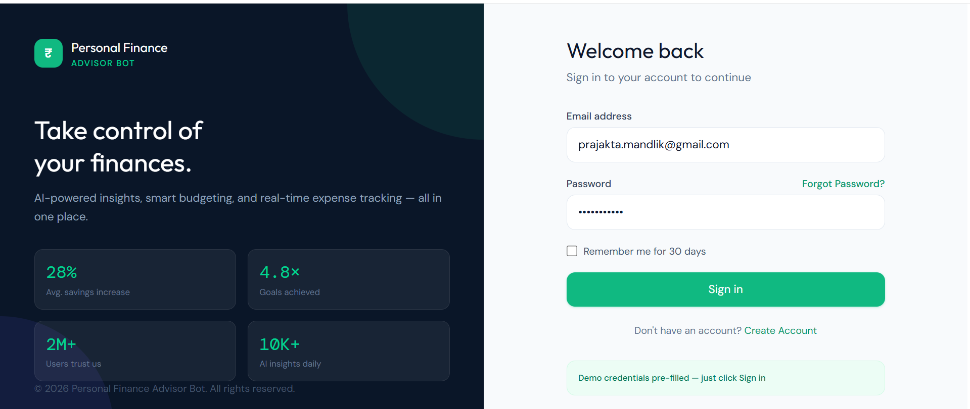
Figure 1. Login screen with pre-filled demonstration credentials.
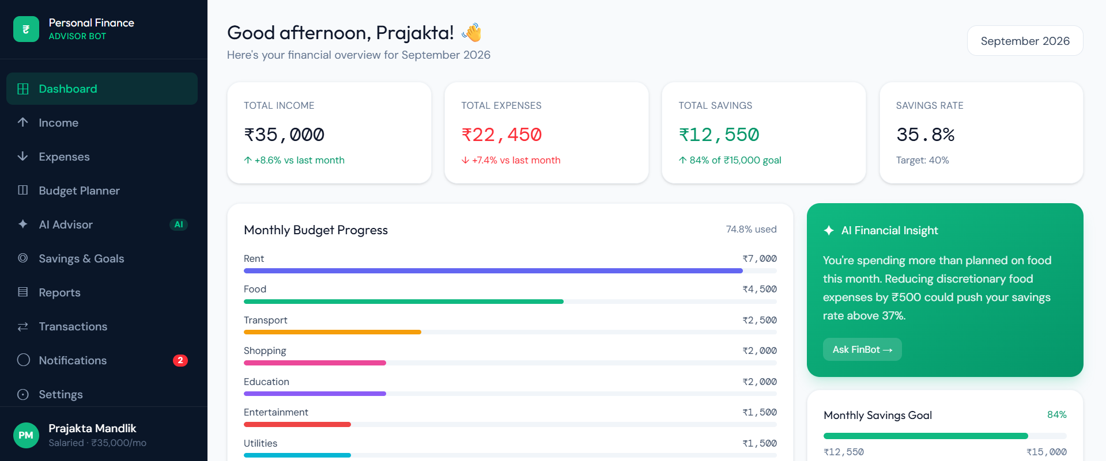
Figure 2. Main dashboard showing September 2026 income, expenses, savings and budget progress.
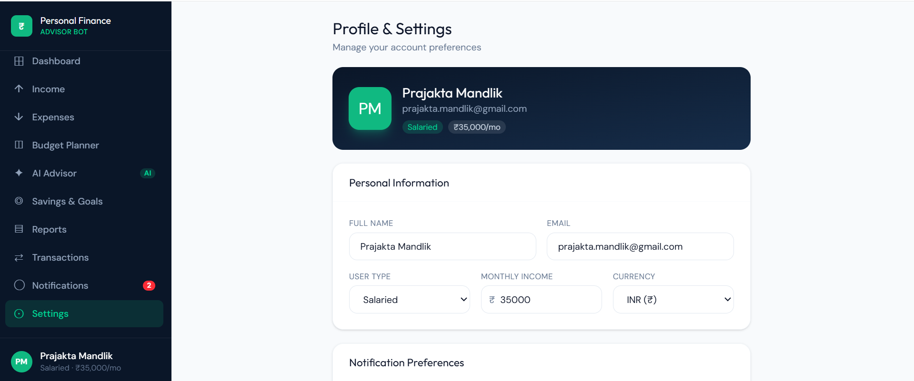
Figure 3. Profile & Settings page with personal information and monthly income.
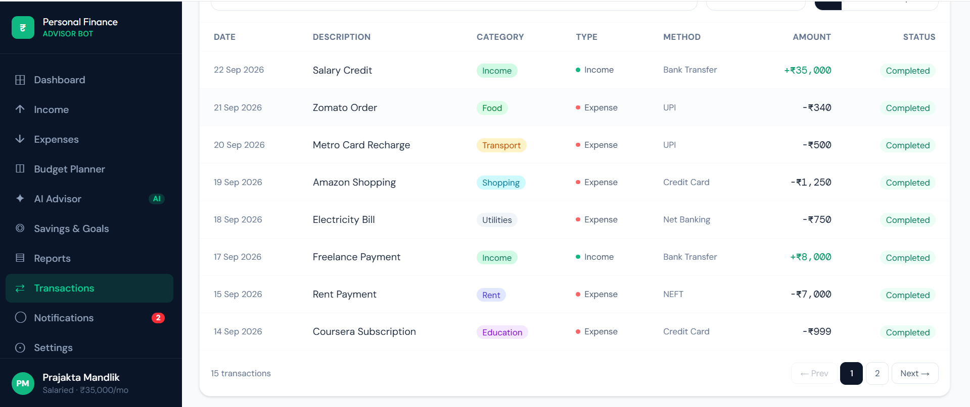
Figure 4. Income management page showing salary and other income sources.

9. Budget Planning and Expense Management
The Budget Planner translates the user's income and spending expectations into category-level budget allocations. It displays planned values, actual spending and remaining budget, making over-budget categories immediately visible.
Figure 5. Budget Planner with category budgets and an over-budget Food & Dining category.
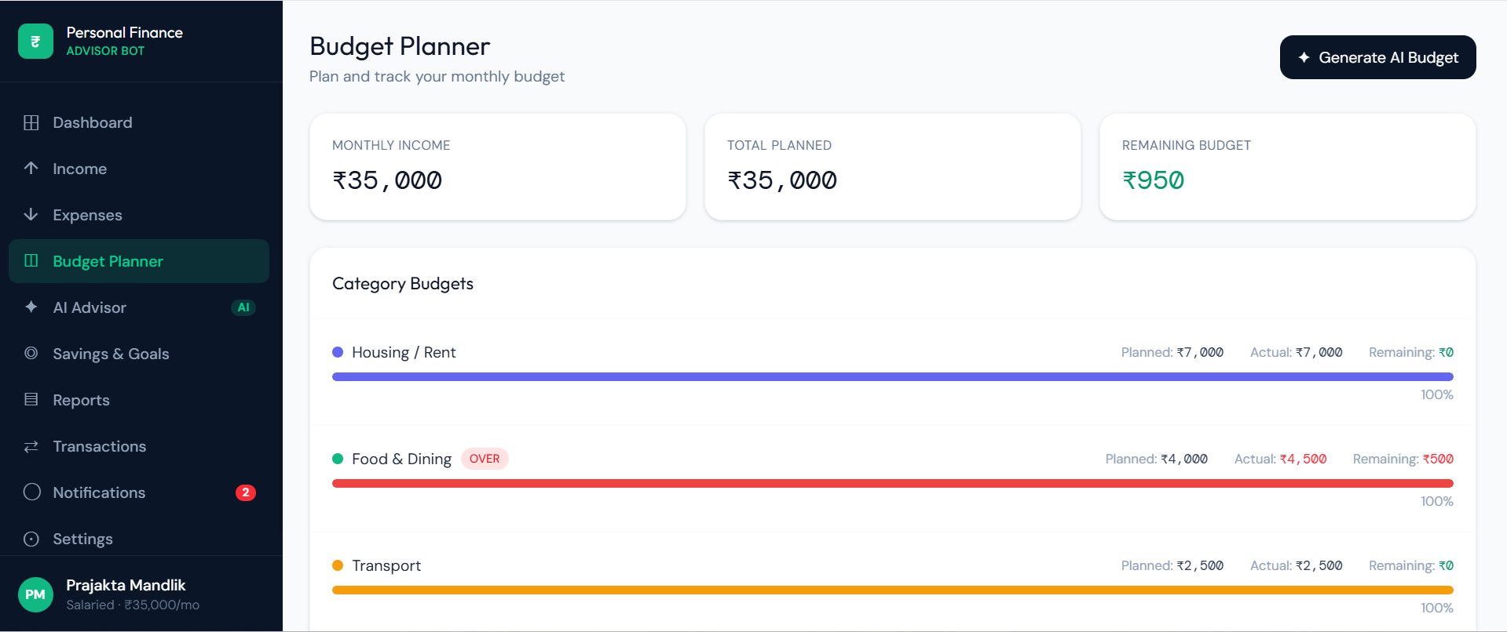
Figure 6. Budget Planner view showing monthly income, total planned budget and remaining budget.
In the supplied demonstration data, Housing/Rent and Transport are shown at their planned limits, while Food & Dining is marked as over budget. This illustrates how the application can surface a specific category for corrective action.

10. Reports and Financial Trends
The Reports module provides a month-over-month view of financial performance and visualizes income, expenses, savings and savings rate. Category trend charts can help users understand how spending behavior changes over time.
Figure 7. Reports page showing month-over-month comparison and spending trends.
The supplied report example compares August 2026 and September 2026 and presents changes in income, expenses, savings and savings rate. The report structure is intended to help users identify changes in financial behavior rather than relying only on a single month's totals.

11. Transactions and Notifications
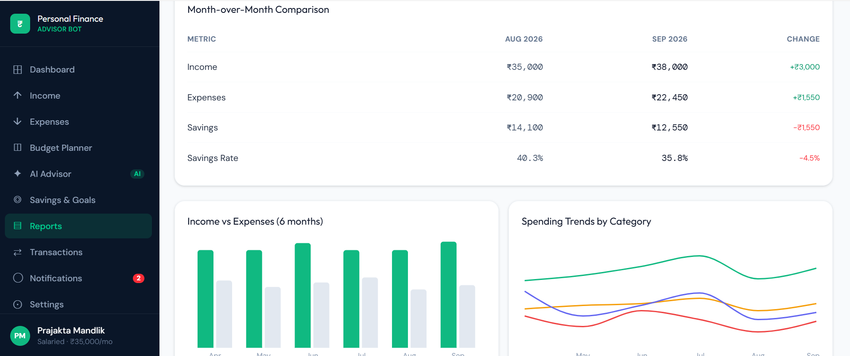
Figure 8. Transactions page with dated income and expense records, categories, methods and statuses.
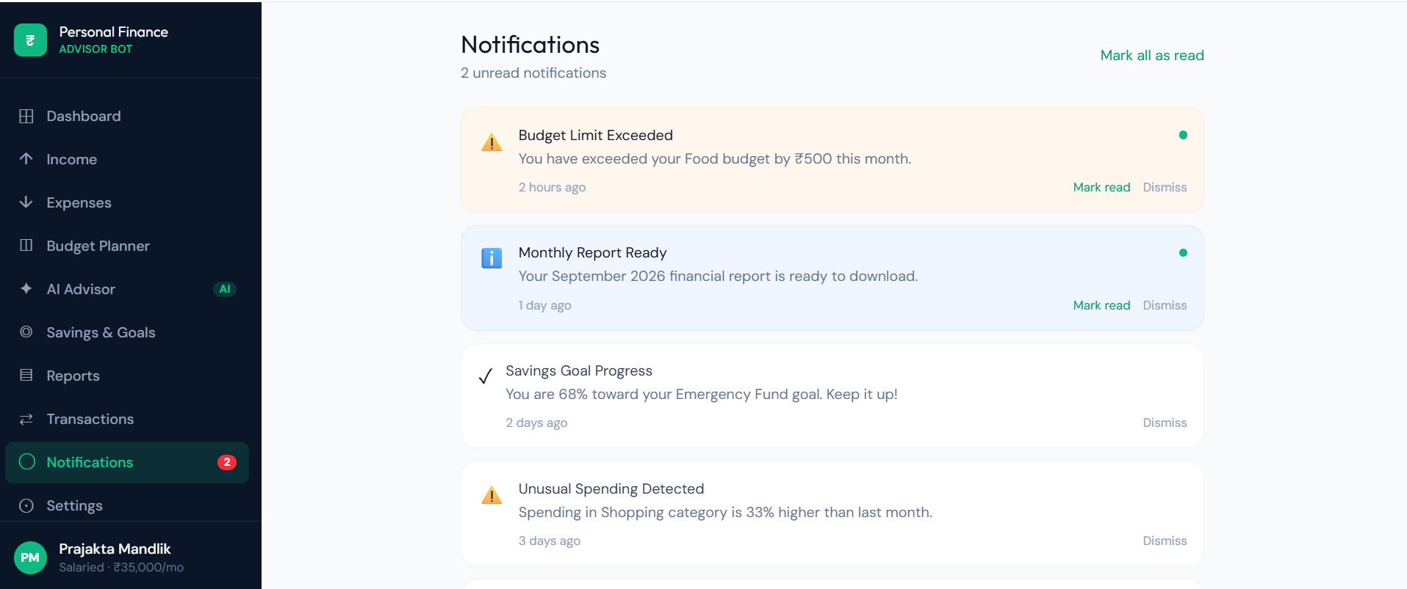
Figure 9. Notifications page showing a budget-limit alert, report readiness, savings progress and unusual spending detection.
The transaction view provides a structured history of financial activity. Notifications add an event-driven layer that draws attention to conditions such as category budget overruns, report availability and unusual spending.

12. AI Financial Advisor
The AI Advisor is the conversational component of the platform. It uses the user's recorded financial information to provide contextual guidance, including ideas for reducing discretionary spending, increasing monthly savings and planning for financial goals.
Figure 10. FinBot conversational interface with AI-generated financial guidance and recommendations.
In the supplied demonstration, the AI assistant discusses food and entertainment spending, current savings progress, and practical changes such as reducing dining-out frequency. The interface also provides quick prompts for common questions.

13. Profile and Settings
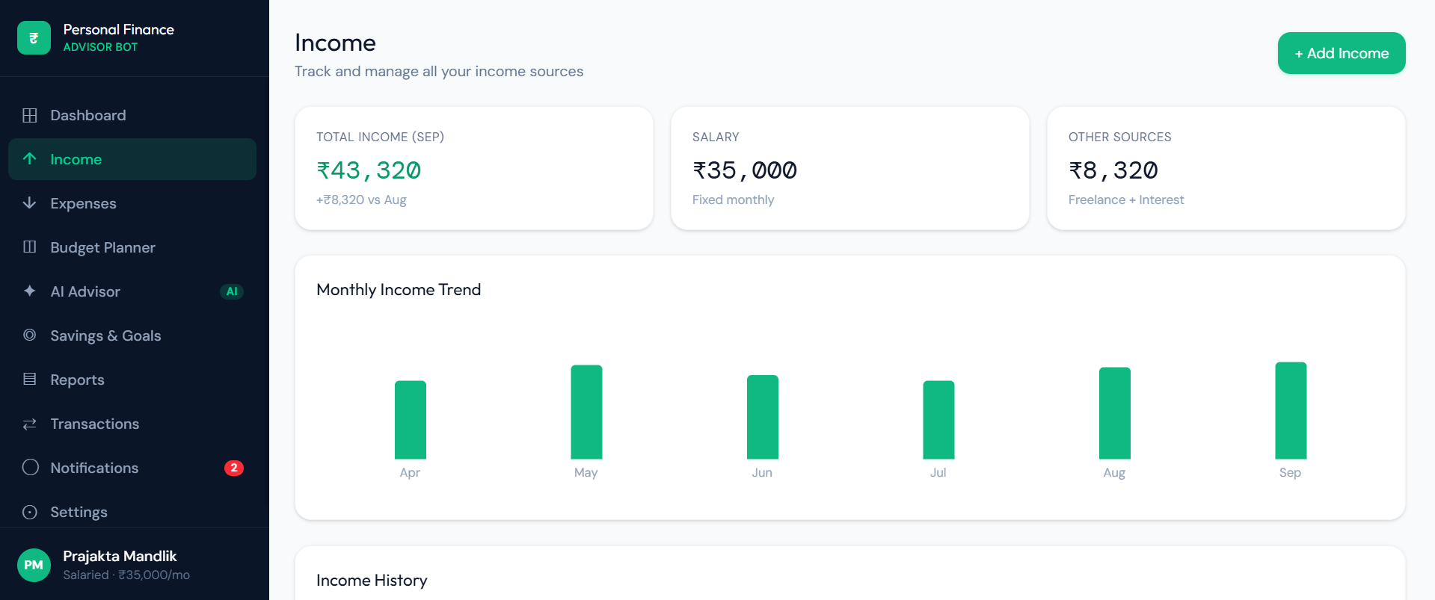
Figure 11. Profile & Settings page for personal information, user type, income and currency.
The Profile & Settings module centralizes account-level information such as full name, email, user type, monthly income and currency. These values can provide the baseline context for budget generation and financial analysis.

14. Project Scenarios

Scenario 1: Salaried Professional
A salaried professional logs monthly income and daily expenses across categories such as rent, food, transport and entertainment. The system analyzes the spending data, identifies overspending areas, and generates a personalized budget plan with actionable saving suggestions. The user receives a monthly summary report showing income vs. expenses, savings achieved and financial goals for the following month.

Scenario 2: College Student
A college student uses the Personal Finance Advisor Bot to manage a limited monthly allowance across essential and discretionary spending categories. The platform helps the student set realistic budget limits, track spending habits and receive AI-powered recommendations for reducing unnecessary expenditures. This enables better financial discipline and improved savings management within a constrained budget.

Scenario 3: Freelancer with Variable Income
A freelancer with variable monthly income uses the platform to log earnings from multiple clients and track project-related expenses. The system adapts budget recommendations based on fluctuating income patterns, highlights months with reduced saving capacity, and suggests strategies for building an emergency fund. By maintaining structured financial tracking, the platform helps improve long-term money management and financial stability.

Scenario 4: Household Manager
A household manager uses the system to monitor shared family income and expenses across categories such as groceries, utilities, education and healthcare. The bot generates a consolidated monthly financial report, identifies budget overruns in specific categories and provides tailored saving strategies to meet family financial goals. This enables better household financial planning, resource allocation and long-term savings improvement.

15. Project Workflow
Step | Activity | Description
Step 1 | User profile setup | Enter user type, monthly income and currency.
Step 2 | Income recording | Record salary and other income sources.
Step 3 | Expense recording | Log transactions and classify them by category.
Step 4 | Budget generation | Create category budgets using available income and financial goals.
Step 5 | Monitoring | Compare actual spending against planned amounts.
Step 6 | Savings tracking | Measure savings against monthly or goal-based targets.
Step 7 | AI analysis | Review AI-generated insights and practical saving recommendations.
Step 8 | Reporting | Review monthly summaries and historical trends.

16. Testing and Verification
Testing should verify both individual financial functions and the integrated user journey. The following test cases are aligned with the supplied system functionality.
ID | Test Area | Input / Condition | Expected Result
T01 | Income Entry | Valid monthly income and an additional income source | Income totals are stored and reflected in the dashboard.
T02 | Expense Entry | Valid expense with category, amount and date | Transaction is stored and category totals are updated.
T03 | Budget Monitoring | Actual spending exceeds a category budget | The category is identified as over budget and a notification can be generated.
T04 | Savings Calculation | Income and expense totals for a month | Savings equals income minus recorded expenses and the savings rate is displayed.
T05 | AI Advisor | Financial question with available spending context | AI assistant returns contextual financial guidance.
T06 | Reports | Two or more months of financial data | Month-over-month comparisons and spending trends are displayed.
T07 | Notifications | Budget overrun or unusual spending condition | Relevant notification is shown with appropriate status.

17. Results and Demonstrated Capabilities
- Centralized personal-finance dashboard.
- Income source tracking, including salary and other sources.
- Categorized expense and transaction management.
- Monthly category-based budget planning.
- Budget-overrun identification and notifications.
- Savings progress monitoring.
- Month-over-month financial reporting.
- Category-level spending trend visualization.
- AI-powered financial insights and saving recommendations.
- Profile and notification preference management.
- A scalable Flask + SQLAlchemy application foundation.

18. Future Enhancements
- Predictive spending analytics based on historical transaction patterns.
- Investment suggestions and educational investment guidance.
- Goal-based savings planning with multiple simultaneous financial goals.
- Advanced AI-driven financial health monitoring.
- Automatic recurring-income and recurring-expense detection.
- More detailed emergency-fund planning.
- Enhanced household and shared-budget support.
- Cloud deployment and operational workflows using AWS tooling.
- More advanced financial reports and export formats.
- Improved personalization of AI recommendations.

19. Security and Responsible Use Considerations
Because the application handles sensitive financial information, a production implementation should protect account credentials, financial records and AI prompts using appropriate authentication, authorization, secure transport, input validation, database access controls and secrets management. AI-generated guidance should be presented as informational assistance rather than a substitute for regulated financial advice, and sensitive data should be handled according to applicable privacy requirements.

20. Conclusion
The Personal Finance Advisor Bot provides an integrated approach to personal financial management by bringing income tracking, expense logging, budget planning, savings monitoring, reporting and AI-assisted guidance into one platform. Its Flask and SQLAlchemy foundation supports a structured backend, while the AI layer adds contextual analysis and practical recommendations.
The supplied interface demonstrates a complete financial-management workflow: users can configure their profile, record income, track transactions, monitor category budgets, review reports, receive notifications and interact with the AI advisor. The architecture is also designed for future expansion into predictive analytics, investment education, goal-based savings and advanced financial-health monitoring.

Appendix A – Screenshot Index
1. Login / Welcome screen
2. Main dashboard
3. Profile & Settings
4. Income management
5. Budget Planner
6. Reports and trends
7. Transactions
8. Notifications
9. AI Advisor / FinBot

Appendix B – Key Demonstration Metrics
Metric | Demonstration Value
Dashboard sample month | September 2026
Dashboard sample income | ₹35,000
Dashboard sample expenses | ₹22,450
Dashboard sample savings | ₹12,550
Dashboard sample savings rate | 35.8%
Budget sample remaining | ₹950
Example savings goal | ₹15,000

End of Project Documentation

